Detailed Design Document

______________________________________

**Product: Internal Transfer**

**Publish Date: 06/06/2017**



**MUFG Union Bank, N.A.**

A member of MUFG, a global financial group

*Table of contents*

1. Design Details 1

2. Service Interfaces 6

3. Business Rules and Use-Case Mapping 7

# Design Details

#### **Initiate – Internal Transfer**

##### **UI-Interaction**

The below diagram represents the UI interaction for the Initiate – Internal Transfer page. It shows the different entry points to this UI, various UI components and the different interactions b/w these components.

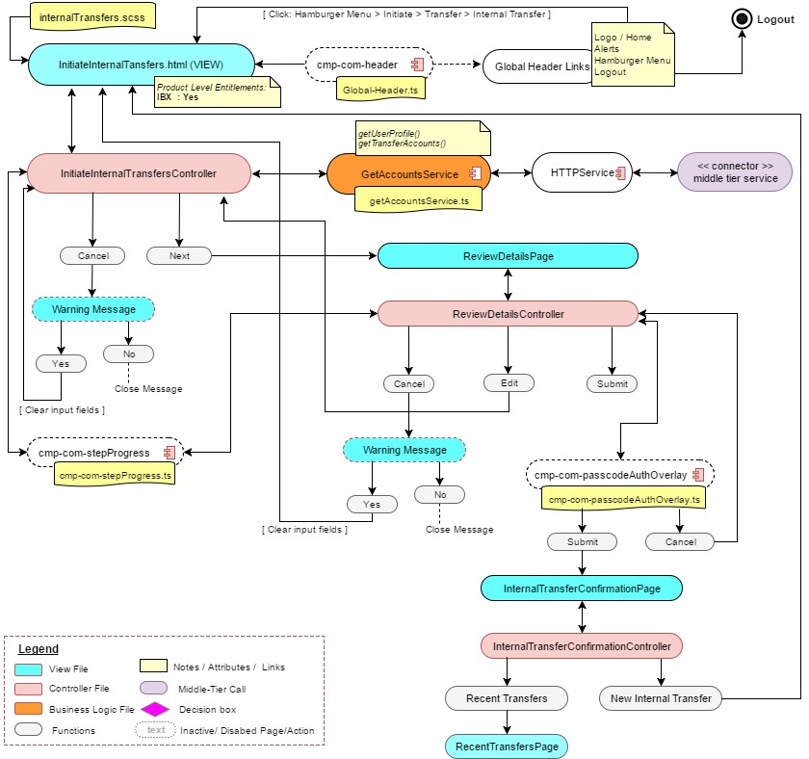

##### **Middle-Tier interaction (sequence diagram)**

The below section represents the calls to get the account, review the transfer and submit transfer for this module.



Refer the Service interface section for service level details

#### **Inquiry – Internal Transfer Inquiry – Released Items** *[Not Currently supported]*

##### **UI-Interaction**

The below diagram represents the UI interaction for the Inquiry – Internal Transfer Inquiry – Released Items Page (tab). It shows the different entry points to this UI, various UI components and the different interactions b/w these components.

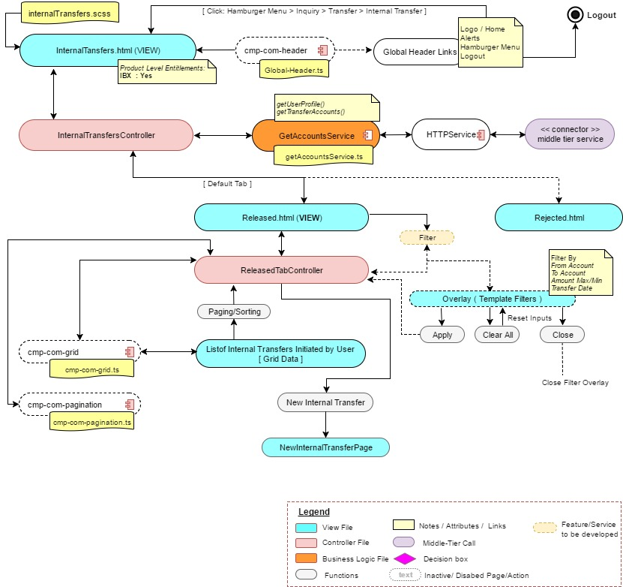

##### **Middle-tier interaction (sequence diagram)**

The below section represents the calls to get the Internal Transfers for Released Items, review the transfer and submit transfer for this module.



Refer the Service interface section for service level details

#### **Inquiry – Interanal Transfer Inquiry – Rejected Items** *[Not currently supported]*

##### **UI-Interaction**

The below diagram represents the UI interaction for the Inquiry – Internal Transfer Inquiry – Rejected Items Page (tab). It shows the different entry points to this UI, various UI components and the different interactions b/w these components.

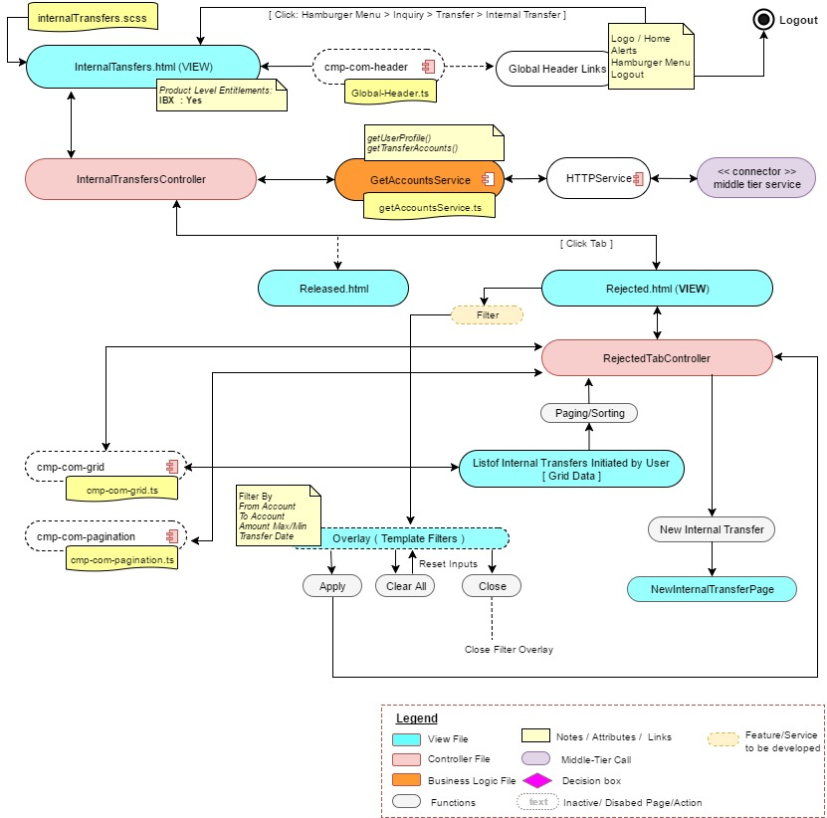

##### **Middle-tier interaction (sequence diagram)**

The below section represents the calls to get the Internal Transfers for Rejected Items, review the transfer and submit transfer for this module.



Refer the Service interface section for service level details

# Service Interfaces

The service information is captured in the attached excel sheet. Refer the attached excel sheet for all the service related information’s. The sheet includes service interfaces that will be developed as new service API from the middle-tier. Along with the backend service details.



# Business Rules and Use-Case Mapping

The following link provides the business rule mapping with the use case from the functional spec document.

